Manipulation of various neural circuits and the effect on behavior in Drosophila using optogenetics: NGSS-Neurons, genetics, and selective stimulations

Zana Majeed^{1,2}, Felicitas Koch³, Joshua Morgan⁴, Robin L. Cooper¹

¹Dept. Biology & Center for Muscle Biology, Univ. KY. Lexington, KY. USA; ²Biol., Univ. Salahaddin, Erbil, Iraq; ³V.M.F., Univ. Leipzig, Leipzig, Germany; ⁴Dept. Electrical Engineering, Univ. KY. Lexington, KY. USA.
Key words: Optogenetics, locomotor activity, Serotonin (5-HT), Glutamate, GABA, acetylcholine.
Acknowledgements
ZRM supported by Higher Committee for Education Development (HCED) scholarship in Iraq. FK supported by Deutscher Akademischer Austausch Dienst (DAAD) German Academic Exchange Service. RISE - Program (Research Internships in Science and Engineering). Personal funds supplied by RLC.

Abstract
The main objective of this education module is to explain principle concepts in neurobiology. A major goal of neurobiology is to understand how neural circuit activity controls corresponding behavior. Drosophila melanogaster is a model system since one can use powerful genetic tools such as UAS-Gal4 system to manipulate various populations of neurons: glutamatergic neurons, serotonergic neurons, GABAergic neurons as well as cholinergic neurons. The optogenetic tool, channelrhodpsin 2 (ChR2), is employed to increase the activity in each of the neuronal types in a spatiotemporal controlled manner in behaving larvae and adult flies. Various behavioral assays are used to observe the effect of specific neuron population activation on crawling behavior in larvae and climbing behavior in adult flies. Students will learn important aspects of controlling neural circuits related to animal behavior. In conducting these activities one will become well acquainted with the actions of different neurotransmitters in the nervous system.

Introduction
Regulation in activating inhibitory and excitatory neurons while monitoring effects on acute and chronic behaviors emphasizes the importance of these neural circuits. To do this type of manipulation within in an organism which is easy to rear and maintain is ideal for hands on inquiry based learning for high school and college courses which emphasize life science topics. This teaching module is designed to integrate modern genetics, engineering, physics, life sciences, modeling and experimental design. Researching the primary scientific literature and the utilizing the related findings as well as postulating the outcome for newly designed experiments based on the results one collects, the students can test their own predictions and draw hypotheses. This approach provides autonomous learning within and among student groups. The measureable outcomes with obtaining quantitative data for analysis and interpretation are a valuable learning experience. Based on one’s findings in the initial experiments one can readily redesign experimental paradigms to test the formulated hypotheses utilizing one’s own prior data. The integration with Arduino hardware and software opens the doors for students to a world of writing code with an experimental purpose and independence in experimental design.

The underlying science in these modules focuses on neurobiology. The seminal discoveries by Hubel and Wiesel (1970) demonstrated that activity in sensory input and within the CNS is indispensable in the development and maintenance of neural circuits. This concept is also essential for development and maintaining synaptic communication at neuromuscular junctions (NMJ) of skeletal muscles (Balice-Gordon et al., 1990; Lomo, 2003). In some cases, the activity profile must occur prior to developmental time points to have plasticity before the neural circuits become more hardwired. After the critical period in synaptic formation, a circuit is not as dependent on activity for competition with other neurons in the establishment of connections. This fundamental phenomenon occurs in organisms from fruit flies to humans. It is known in mice that even after established connections are made as adults that the terminals at NMJs are not fixed to a given location on the muscle fiber. The motor nerve terminals grow out and pull back repeatable over time while continuing to communicate with the muscle fibers (Lichtman and Sanes, 2003).

If motor neurons which are normally innervating a muscle are removed then other motor neurons will take control of the target and innervate it. Thus, motor nerves are searching out targets not already committed by other synaptic inputs (Chang and Keshishian, 1996). This was examined in embryonic and larval Drosophila by laser ablating various body wall muscle fibers during development. Even pharmacologically activating or silencing neural circuits during development can have long term consequences in neural connections and overall physiological functions (Smith et al., 2015). For example, exposing rodents to nicotine during development changes the dendritic morphology within the CNS which lasts into adulthood (McDonald et al., 2005). Even short exposures in the juvenile stages have long lasting effects in adults for these mice (Ehlinger et al., 2014). It is also established that collective synchronized synaptic activity is important for development of the neural structure (Winnubst et al., 2015). Thus, long term consequences in the established neural circuitry within the CNS and at the NMJ can occur based on neural activity when the initial circuits are being wired.

A guided self-inquiry based approach to learning science has been demonstrated to being a very effective means for student learning over the long term (Bradforth, et al., 2015; Waldrop 2015). The engineering design with the Arduino systems is a very engaging educational experience sought after in many schools within the USA and abroad. Students can design the experiments with various computer codes to control the duration of light on-off time period and frequency of stimulation to observe how activating or inhibiting specific sets of neurons can alter development and behavior of the Drosophila larvae or adults. The hardware for the Arduino and associated LED required hardware is relatively inexpensive <$20 USD for an individual unit. There are dozens of demonstration videos on YouTube for a wide variety of inventions and coding using Arduino.

In this educational module, we demonstrate and approach with optogenetics to selectively activate the neurons synthesizing the neurotransmitter GABA, glutamate, serotonin, and acetylcholine. The approach used to stimulate these selective neurons is to activate light sensitive channels expressed in these neurons. Different Drosophila lines will be used for each type of neurotransmitter. The ability to control the stimulation with light is to be managed by Arduino system the students can program or a simplified version with an LED connected to a small battery. Since many of the experimental paradigms will be novel and many unanswered questions remain to be answered in neurobiology, students may uncover unique findings worthy of publication in scientific journals.
This educational module is also designed to embrace the Next Generation Science Standards (NGSS Lead States, 2013) through approaches scientists employ in the development of scientific knowledge. The participants for this exercise will be able to construct models in the neural circuits to explain the observed behavioral phenomenon to make sense of what they observe. The direct real life examples with how neural circuits develop in one’s self as well as in other animals is of general interest but also has applied implications for medicine and health. The ability to manipulate various neurotransmitter systems and stimulation paradigms promotes experimental design and redesign based on the observed findings from each experiment. This is an integral aspect of the NGSS. This approach promotes explanations of the findings in order to set a new or altered stimulation paradigm as participants continue to study a phenomenon in different contexts. NGSS recommends that models be used in Developing, Evaluating, Using, and Revising explanations and predictions of science phenomena.

Materials and Methods

Fly strain and crosses

Some of the experimental procedures require being able to make selective genetic crosses of two different lines. To perform the crosses it may be necessary to identify male and female adults and to be able to obtain virgin females (Figure 1). The instructors of the course can decide on their resources (dissecting microscopes and time management of students) for either performing the crosses themselves or if the students should be given the time to make the crosses. As a learning experience the teacher could allow the students to try these procedures but have a cross already prepared for class use. A number of online resources are available to see the differences in males and female adult flies. We most look for the black tuft if hairs on the forelegs of the male fly (Figure 1). It is good to compare the flies side by side to tell the differences.

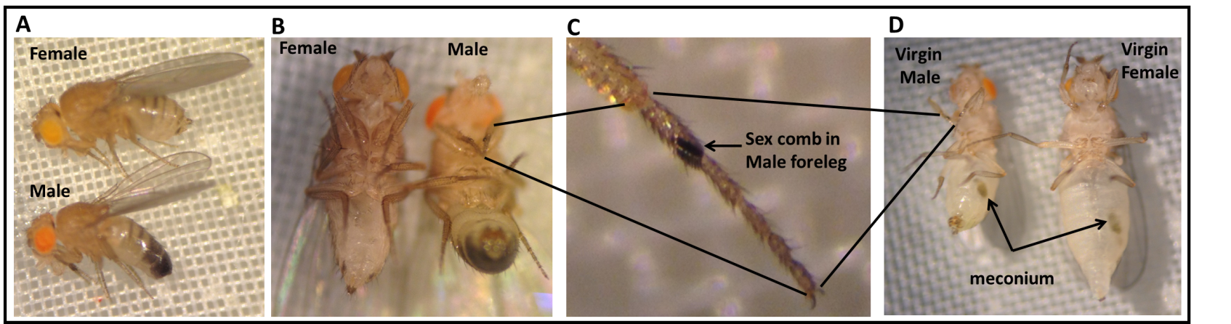

Figure 1: (A) (Lateral view) Morphological characteristics and sexual dimorphism of adult Drosophila melanogaster. Adult female fly (top) has a light colored abdomen region; however, adult male fly (bottom) has a dark posterior abdomen region. (B) (ventral view) Shows morphological differences between male and female flies. (C) Magnified view of the male fly foreleg shows male specific sex comb structure. (D) Newly eclosed male and female adult flies which have meconium. Male has a pointed brown colored posterior region.

There are some procedures where the fly lines obtained can be directly examined without having to make filial 1 ( F1) generations with selective crosses. The lines which are OK371-Gal4;UAS-ChR2H134R-mcherry ( homozygous line, there are two copies for each construct), which expresses the light-activated channelrhodopsin-2 in motor neurons. This line is made by crossing w¹¹¹⁸;P{GawB}VGlut^{OK371} (BDSC stock # 26160) with w*; P{UAS-H134R-ChR2}2 (BDSC stock # 28995 Pulver et al., 2011). We used another recently created ChR2 line which is very sensitive to light called y¹ w¹¹¹⁸; PBac{UAS-ChR2.XXL}VK00018 (BDSC stock # 58374) (Dawydow et al., 2014). Virgin females from w*; P{UAS-H134R-ChR2}2 were crossed with males of D42-Gal4 (BDSC stock#8816), Trh-Gal4 (BDSC stock#38389), Gad1-Gal4 (BDSC stock# 51630, or ppk-Gal4(BDSC stock# 32078) line to express ChR2-XXL variant in motor neurons, serotonergic neurons, GABAergic neurons or Type IV sensory neurons, respectively. We also used UAS-H134R-ChR2;Trh-Gal4 (III) homozygous line, which is kindly provided by Dr. Andreas Schoofs (Schoofs et al., 2014), to compare its behavioral effects with more sensitive ChR2 line.

Table 1: Drosophila melanogaster lines

Line Sex Outcome

w¹¹¹⁸;P{GawB}VGlut^{OK371} Male or Female ChR expressed in neurons which express vesicular
Cross with line below opposite sex transporter for glutamate (motor neurons).

w*; P{UAS-H134R-ChR2}2 Male or Female

y¹ w¹¹¹⁸; PBac{UAS-ChR2.XXL}VK00018 Virgin Female
Cross with below lines
D42-Gal4 Male ChR2 expressed in motor neurons.
Trh-Gal4 Male ChR2 expressed in serotonergic neurons
Gad1-Gal4 Male ChR2 expressed in GABAergic neurons
ppk-Gal4 Male ChR2 expressed in Type IV sensory neurons

w*; P{UAS-H134R-ChR2}2; Trh-Gal4 (homozygous line) ChR2 expressed in serotonergic neurons.
There is no need to make crosses as this line is homozygous. The larvae or adults should be raised on food supplemented with all trans retinal (ATR), which is a cofactor essential for ChR2 function, since unlike mammals the flies cannot synthesize sufficient amount of ATR for ChR2 function) and a control group without ATR (use ethanol (EtOH) as a vehicle since ATR is dissolved inside absolute ethanol).

All trans retinal preparation

All trans retinal (500 mg), which was purchased from Sigma-Aldrich, St. Louis, MO, USA), is dissolved in 17.6 ml absolute ethanol to make 100 mM stock solutions. 100 µl of 100 mM stock solution is transferred to small tubes and wrapped in aluminum foil and kept in -20ºC freezer. The ATR should be kept away from light since it is sensitive to light and it would be degraded, thus becoming ineffective if it is exposed to light for a long time.

Preparation of fly food supplemented with ATR
In order to prepare fly food supplemented with 1 mM ATR, 10 mL fly food is dissolved in microwave. The food is left to cool down, then 100 µl of 100 mM ATR is mixed well with fly food or 100 µl of absolute ethanol is mixed with food as a control. The food vial is wrapped in aluminum foil then the food is left until it was solidified well; otherwise the flies get stuck in the wet food. The flies are transferred from its vial to ATR containing vial and kept in a dark place (to keep the ATR from degradation) at room temperature 22-23ºC.

Larval locomotion behavior

Locomotion behavior is assessed by placing a single larva on an apple-juice agar plate. The larva is left for one minute to acclimate to the new environment. The body wall contractions are being counted for one minute (BWCs/min) while the larva is being exposed to regular light. Then the body wall contractions are counted for one minute while larvae are being exposed to blue light (470nm wavelength) (a dispersed-soda-can device). Also, body wall contractions are being counted while the larva was being exposed to focused focal blue light (a focused light through a microscope eyepiece with a mounted LED). This assay was performed for first, second and third instar larva. The microscope eyepiece can be bought on Amazon.com as 10X eyepieces. Try to look for the wide opening type so the LED can fit down inside.

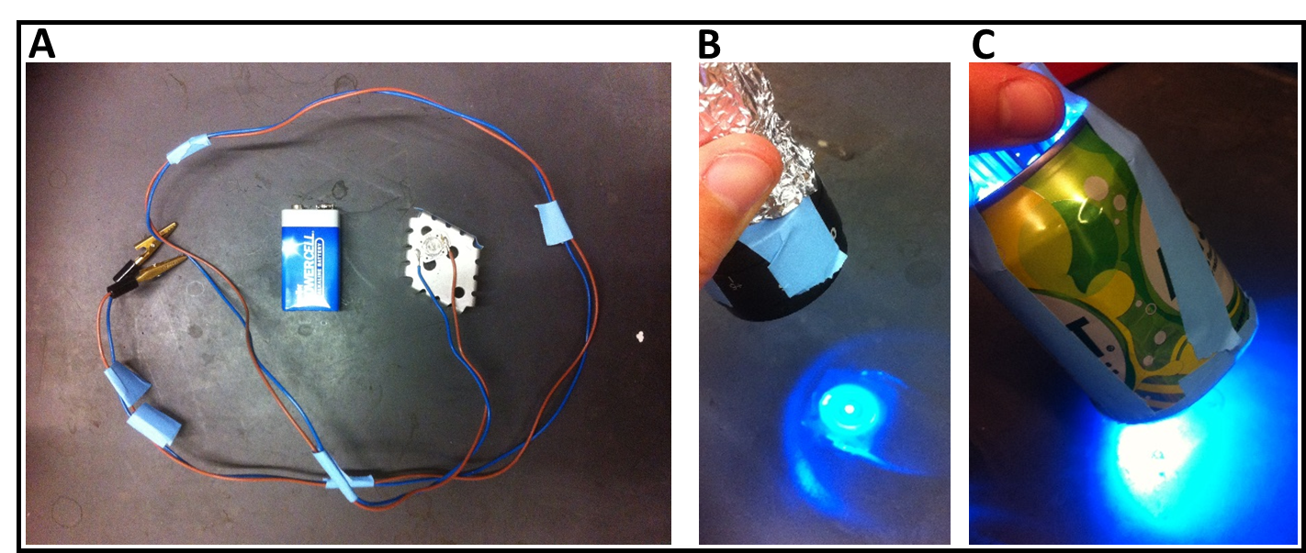

Figure 2: (A) The blue light emitting diode (LED) (wavelength = 470nm) is glued on a cooler plate with a temperature resistant glue. The LED light is connected to a 9V battery. Various intensity of LED light can be used by attaching the LED (B) to microscope ocular lens, which gives off high intensity light or (C) soda can, which gives low intensity dispersed light.

Rolling behavior in larvae

The rolling behavior is performed by placing a single larva on the surface of an apple-juice agar plate. The occurrence of rolling behavior is counted for 1st and 2nd minute. The percentage of larvae that show rolling behavior should be presented in a graphical form.

Table 2: Larval behaviors with exciting the various neurons expressing different types of neurotransmitters.

Dim or regular light /1min

Low intensity blue light /1min

Dim or regular light /1min

High intensity blue light /1min

Dim or regular light /1min

Neuron type

OK371-Gal4 (appropriate neurotransmitter line) and UAS-ChR2H134
Soda can
motor neurons ? ? ? ? ?

Focuses light
motor neurons ? ? ? ? ?

y¹ w¹¹¹⁸; PBac{UAS-ChR2.XXL}VK00018 crossed with appropriate neurotransmitter line
Soda can
motor neurons ? ? ? ? ?
serotonergic neurons ? ? ? ? ?
GABAergic neurons ? ? ? ? ?
Type IV sensory neurons ? ? ? ? ?

Focuses light
motor neurons ? ? ? ? ?
serotonergic neurons ? ? ? ? ?
GABAergic neurons ? ? ? ? ?
Type IV sensory neurons ? ? ? ? ?

UAS-ChR2H134R-mcherry;
Soda can
Serotonergic neurons ? ? ? ? ?

Focused light

Serotonergic neurons ? ? ? ? ?

Type of behavior coding used: continue crawling forward (CC), crawling backward (CB), stop (S), head wagging (HW), rolling (R) , keeps turning left or right while crawling (T).

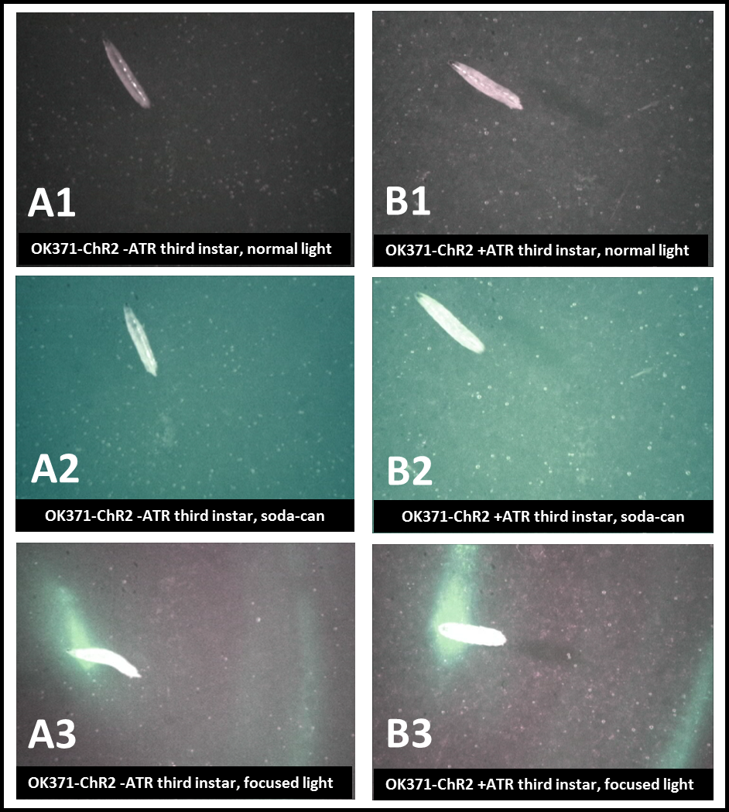

Figure 3: Activation of ChR2 channels in motor neuron of third instar larva.OK371-Gal4 (Gal4 driver specific for motor neurons) is crossed with UAS-ChR2H134R-mcherry line (This line is homozygous for both Gal4 and UAS constructs). The progeny is expressing ChR2 in motor neurons. (A) The larvae were raised in a fly food which was not supplemented with all trans retinal (ATR), which is a cofactor important for ChR2 membrane integration and function. (A1)The body wall contractions are counted on an apple juice agar plate for 1min when the larva exposed to regular light. (A2) The larvae is being exposed to low intensity blue LED light (470nm) for 1min while the BWCs are being counted. (A3) The crawling behavior of larva is being observed while it is being exposed to intense blue light for 1min. (B) The larva was fed ATR (1mM), which is mixed with fly food. The body wall contractions are being counted when the lava is being exposed to regular light (B1), low intensity blue light (B2), or high intensity blue light (B3). The lave does not respond to the low intensity light although when it is being exposed to high intensity blue light, the body wall muscles contract which can be observed by shortened body length (B3).

Adult fly behavior assays

For the adult behaviors one can put the left over larvae from conducting the larval behaviors back into the food vial in which they were taken for later conducting adult behaviors. One needs to save the 1st crosses and wait until they become adults. Thus, one can directly compare the differences from the larval lines and the adult lines with the same crosses. Also, if one saved the ATR tainted food from the larval assays this can be used to feed the adults. The adults should be a few days old before conducting these behavioral experiments to insure they have built back up the levels of ATR in the body as the ATR might be degraded in the pupa stage. There are a number of behavioral assays which are commonly used for adult Drosophila (Badre and Cooper, 2008; Nichols et al., 2012; http://www.sdbonline.org/sites/fly/aimain/6behavior.htm). For some of the assays, one should consider separating males and females as there are differences in the size and weight of the adult flies. Also, as the adults age they maybe differences in the behaviors.

The two commonly used behaviors which are relatively easy to implement, but informative for the biological concepts are the negative geotaxic and phototaxic assays which are described below. These assays can be expanded on for deeper in vestigations into the neurobiology. Also these allow for data gathering, redesign and vivid discussion for inquiry based labs.

Negative geotaxic assay- The adult flies aged 2-8 days are to be anesthetized with ice or CO₂. The males and females are to be sorted out and transferred into separate vials in cohorts of 10-14 flies. The flies should be left to recover for 24h before running the experiments. A plastic vial (Drosophila culture cylindrical vial 1-1/4" diameter x 4" tall; http://www.enasco.com/product/SB11136M is marked at 8cm length, and the 8-10 cohort flies are transferred to that empty marked vial. Another plastic vial is placed on top of the marked one (Figure 3) (Ali et al., 2011). The flies are left for one minute. The vials are tapped to knock down the flies to the bottom of the tube. Then number of flies which climbed across the 8 cm mark is recorded for 10 sec. (Figure 4). This procedure is repeated three times. The data should be graphed. An schematic example for UAS-ChR2-XXL/+;D42-Gal4/+ flies exposed to blue light and showing the recovery to crossing the 8 cm marked line see Figure 4.
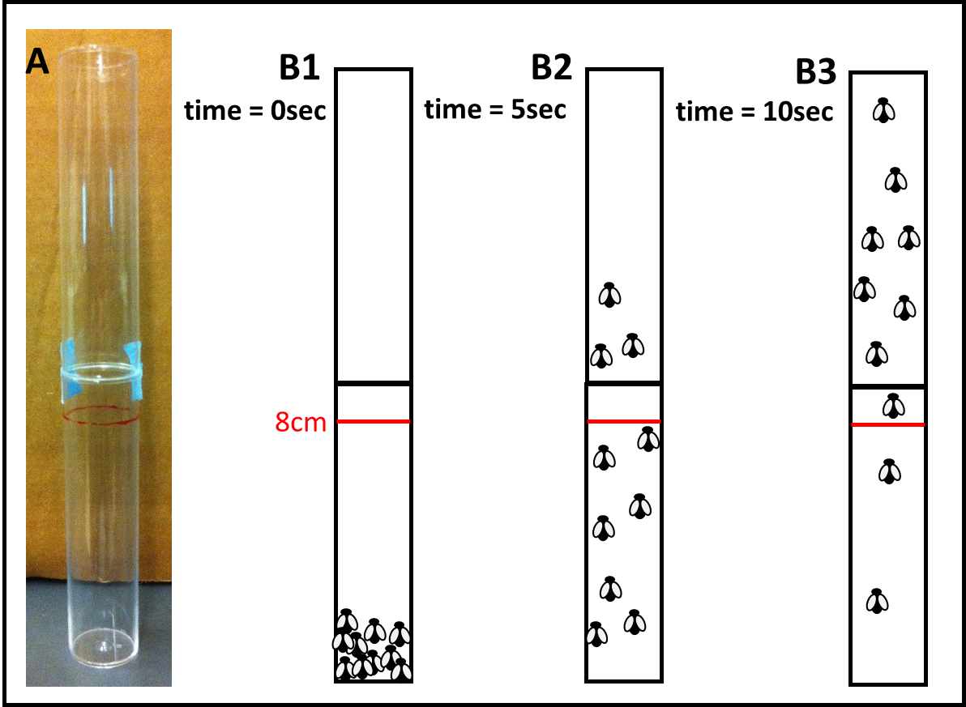
Figure 4: Negative geotaxic assay in adult flies. (A) Two plastic vials are put together for this assay. 10-14 adult male or females flies are transferred to an empty plastic tube which is marked at 8 cm length. Second plastic tube is put on the top of the first marked plastic tube and sealed with tape. (B1-B3) The tube is tapped until all the flies fall into the bottom of the first tube (B1). The flies start climbing up on the wall of the plastic tubes. After 10 seconds the number of the flies that cross the 8 cm red line is counted which shows the percentage of the flies that are crossed the line in 10 sec. (B1) 0 %, (B2) 30 %, (B3) 8% of the flies are crossed the red line.

Table 3: Representative sample data for the negative geotaxic assay with various neuron population activation by light.

Neuron type Time taken to cross 8 cm line (10 trials before blue light exposure, 10 trials after blue light exposure)

OK371-Gal4 (appropriate neurotransmitter line) and UAS-ChR2H134R-mcherry
Soda can
motor neurons ?

Focused light
motor neurons ?

y¹ w¹¹¹⁸; PBac{UAS-ChR2.XXL}VK00018 crossed with appropriate neurotransmitter line
Soda can (low intensity)
motor neurons ?
serotonergic neurons ?
GABAergic neurons ?
Type IV sensory neurons ?

Focused light (high intensity)
motor neurons ?
serotonergic neurons ?
GABAergic neurons ?
Type IV sensory neurons ?

UAS-ChR2H134R-mcherry;
Soda can
Serotonergic neurons ?

Focused light
Serotonergic neurons ?

Phototaxic assay- A device with a 25 cm long plastic tube and light source at one end in a dim-light room is used to assess the phototaxic behavior of the adult flies. The tube is narrow enough not to allow the adults to fly but only walk along the tube. Also the standard small LED maglight fits snuggly in one end (Figure 5). The male or female flies are anesthetized by ice for 25-30 sec. Individual flies are placed in each apparatus. The flies are left to recover for at least 10 min. Each apparatus with individual fly, which is positioned horizontally or vertically, is tapped until the fly fall to the bottom of the tube, which was closed by a rubber stopper. The time the fly crossed 10 cm line and 20 cm line is recorded. This apparatus could be positioned horizontally or vertically, but vertical placement examines both geotaxic as well as light sensitivity. The data obtained should be graphed.

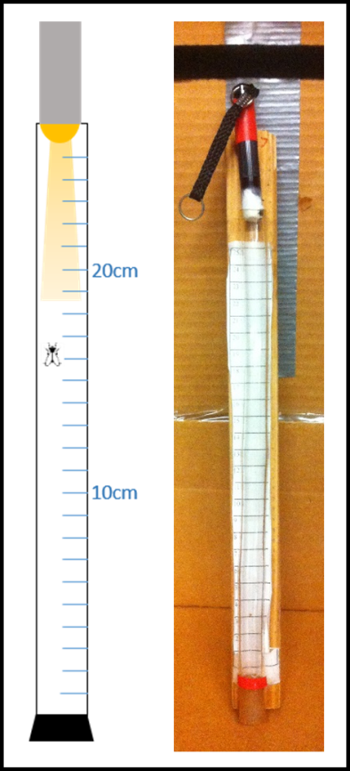

Figure 5: The experimental set up for adult phototaxic assay in a narrow tube. A single male or female fly is transferred in the tube. The tube is tapped until the fly falls into the bottom. The time that it would take to reach 10 cm and 20 cm is recorded.

Neuron type Time taken to cross 10 cm line and 20 cm lines

10 cm 20 cm
OK371-Gal4 (appropriate neurotransmitter line) and UAS-ChR2H134R-mcherry
Soda can
motor neurons ? ?

Focused light
motor neurons ? ?

y¹ w¹¹¹⁸; PBac{UAS-ChR2.XXL}VK00018 crossed with appropriate neurotransmitter line
Soda can
motor neurons ? ?
serotonergic neurons ? ?
GABAergic neurons ? ?
Type IV sensory neurons ? ?

Focused light
motor neurons ? ?
serotonergic neurons ? ?
GABAergic neurons ? ?
Type IV sensory neurons ? ?

UAS-ChR2H134R-mcherry;
Soda can
Serotonergic neurons ? ?

Focused light
Serotonergic neurons ? ?

Data collection and interpretation
The results from the various experiments highlighted can be tabulated or graphed in various ways depending on the variables one wishes to investigate. Data which can be plotted over time, such as time for the adults to cross the 10 and 20 cm line, can be graphed with free web based graphing software “Joinpoint” which allows students to work at home or at school. Also, graphing the values for the different experimental lines of flies allows for discussion of the data in relation to the biological significance. These excercises provide an inquiry based experience relating to real life topics and can be related to investigations of practical neurobiological phenomenon in relation to human disorders (Parkinson’s, Stiff man syndrome, epilepsy, and autism) along with medical interventions with pharmacological agents on these various neurotransmitter systems. Conducting a literature search on the transmitter systems and how sensory-motor neural circuits function can help to make predictions of the behavioral outcomes when stimulating the particular subsets of neurotransmitter systems for the larva and adults before conducting the experiments on the animals. This establishing a conceptual model of the neurotransmitter and the neural circuits related to the mammalian behavior and then testing if the model hold for the Drosophila is an important concept of the NGSS in the use of models and redesigning to observations (Krajcik & Merritt, 2012; NGSS Lead States, 2013).

The following are examples of data collected for various experiments related to these protocols in a research lab environment with controlling as many variables as possible which can be difficult in a teaching laboratory. Ideas in how one may graph the data can also be obtained by examining these graphs for the carious experimental paradigms.

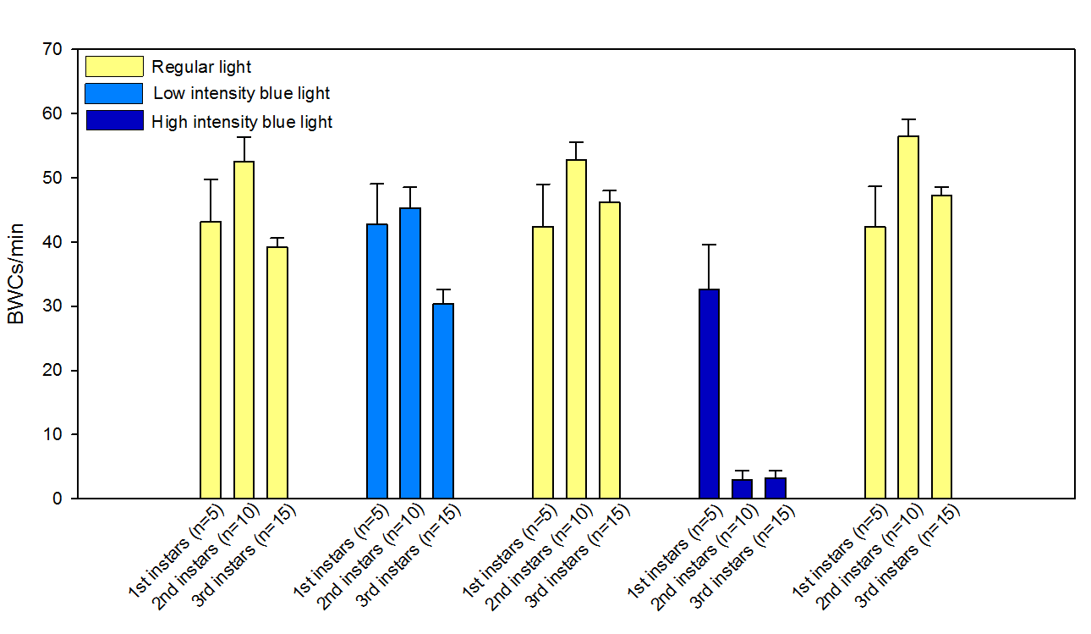
Figure 6: Activation of ChR2 channels in motor neurons (UAS-ChR2H134R-mcherry;OK371-Gal4) produces different responses in various instar larvae (The larvae were fed ATR 1 mM). The body wall contractions for one minute (BWCs/min) were counted while the larva was exposed to regular light, low intensity blue light or high intensity blue light. The data shows that the first instar larvae do not respond well to even high intensity blue light.

To understand the effects of the neurons driving skeletal muscles, which relates to movements of the larvae, an example of a recording with an intracellular electrode in a body wall muscle depicts the neural activity to the skeletal muscle.

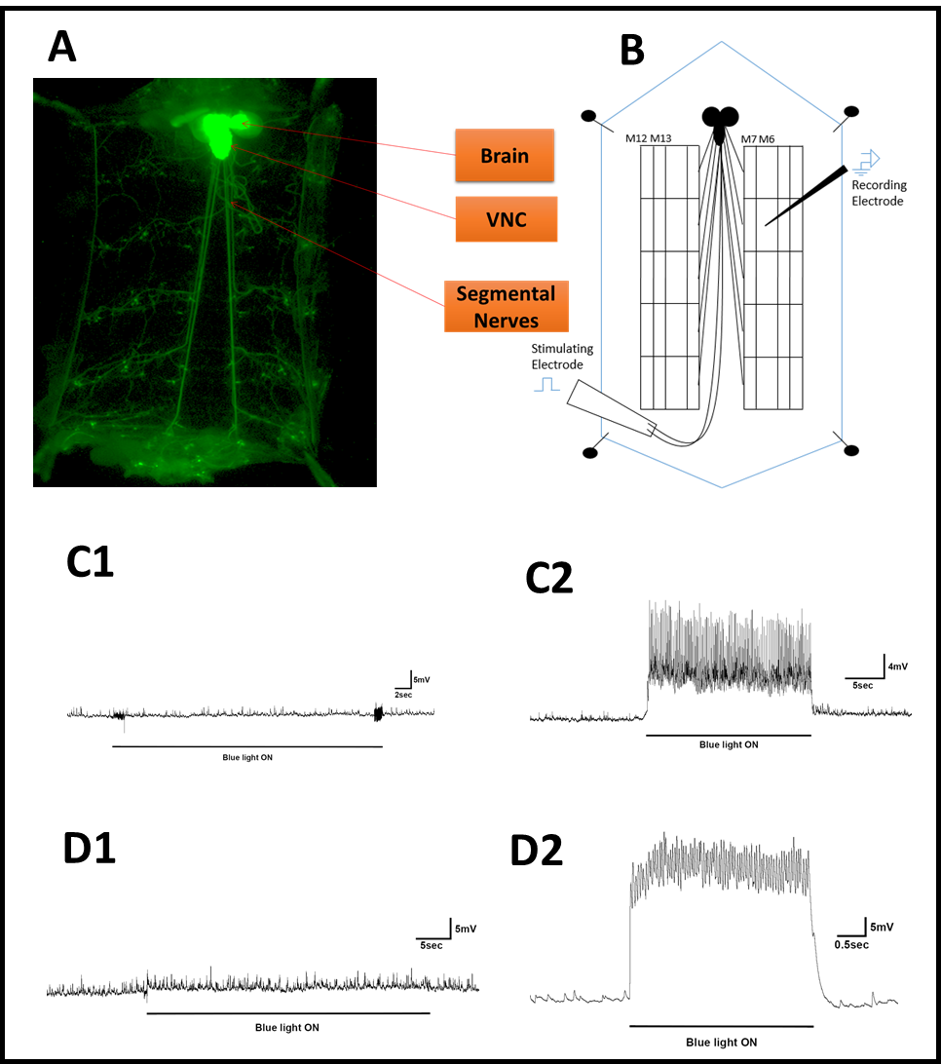

Figure 7: (A) The nervous system in Drosophila melanogaster third instar larvae expressing green fluorescent protein (GFP) in the whole nervous system. (B) Dissected third instar larvae shows m6 muscle fibers and intracellular microelectrode to record excitatory postsynaptic potentials (EPSPs) while the ChR2 in motor neurons are being activated by blue light exposure. (C1) Intracellular recording in OK371-ChR2 minus ATR (CNS intact) third instar larvae. The blue light (low intensity) exposure does not produce any postsynaptic responses in muscle fiber M6 since the larvae is not fed ATR, which is a required supplementation for the action of ChR2. (C2) Intracellular recording in OK371-ChR2 plus ATR 1 mM (CNS intact) third instar larvae. Blue light (low intensity) exposure produces responses in M6 muscle fiber which is presented as excitatory postsynaptic potentials (EPSPs). (D1) Intracellular recording from M6 fiber muscle in OK371-ChR2 minus ATR (CNS intact) third instar larva. Blue light (high intensity) exposure does not activate motor neurons. No EPSPs are seen in this trace although the miniature EPSPs are still present. (D2) The evoked response is being recorded in OK371-ChR2 plus ATR 1mM (CNS intact) third instar larvae while it is being exposed to blue light (high intensity).

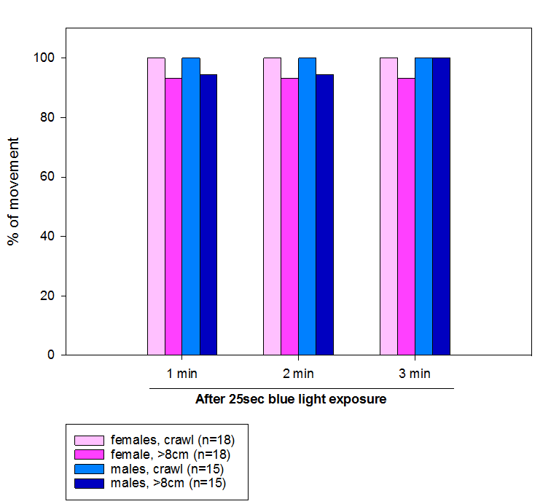

Figure 8: Locomotor activity in adult male and female flies after exposure to blue light. These flies are expressing ChR2 in motor neurons and are fed ATR 1 mM (UAS-CHR2H134R-mcherry;OK371-Gal4). The blue light does not exert influence on the negative geotaxic assay since the blue light cannot penetrate well the thick dark adult cuticle.

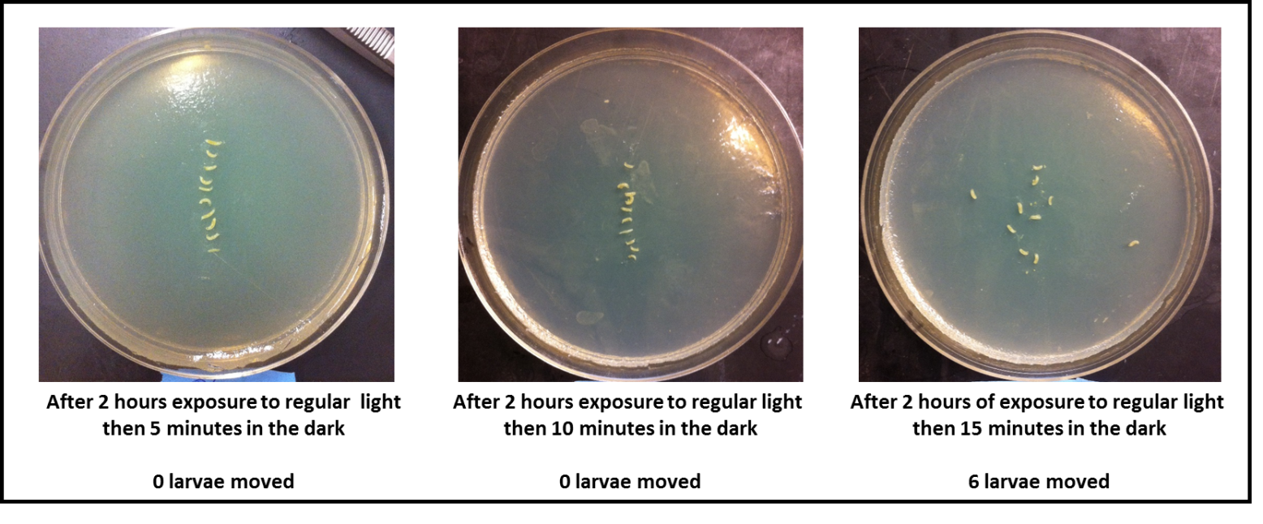

Figure 9: Locomotor activity in third instar larvae expressing ChR2 in motor neurons (UAS-ChR2-XXL;D42-Gal4). When the larvae were exposed to regular light, they were all contracted and did not move (n=30, 10 larvae per agar plate per condition). 10 third instar larvae were placed on an apple juice agar plate. The Larvae were exposed to regular light for 2 hrs. The larvae were stayed in their location without any movement. Three different conditions were used to show how much time it would take for the larvae to start moving again after 2 hr regular light exposure. The data shows that it takes about 15 min for the larvae to restore their locomotor activity.

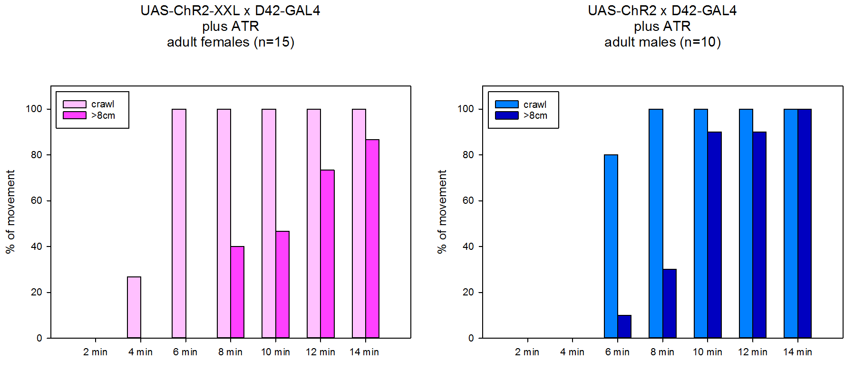
A
B

Figure 10: Activation of highly sensitive ChR2 in motor neurons (UAS-CHR2-XXL;D42-Gal4. (A) The crawling and negative geotaxic behavior of adult female flies is decreased after 25 sec blue light (low intensity) exposure. After 14 min the flies restored their normal climbing ability. (B) The ability to crawl and climb was markedly compromised in adult male flies being exposed to blue light for 25 sec. The crawling ability restored after 6 min of paralysis although the climbing behavior went back to normal after 12 min of paralysis. These flies were raised of food supplemented with ATR 1 mM.

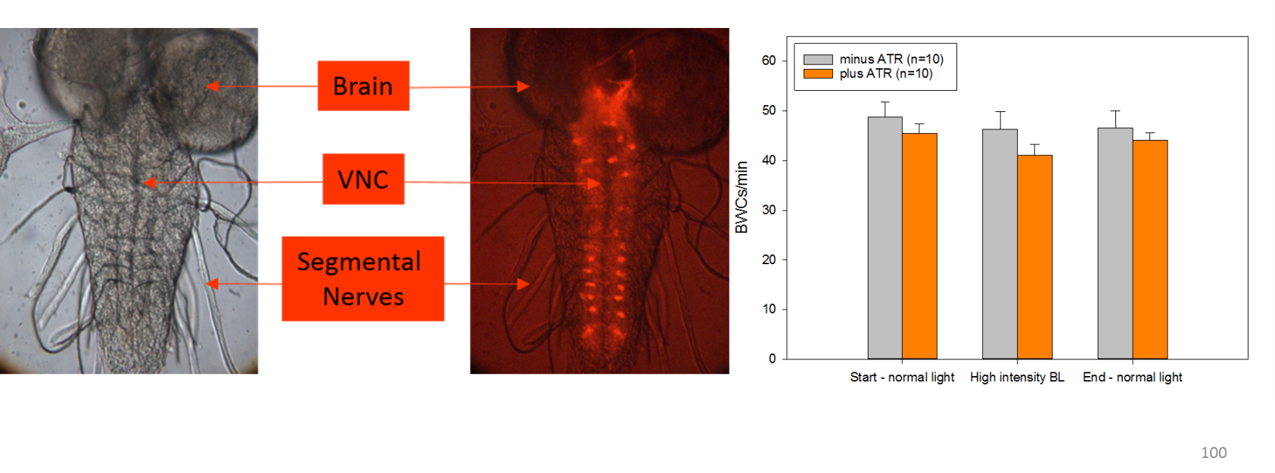
B
A2
A1

Figure 11: (A1) Central nervous system in third instar larva. (A2) Serotonergic neurons expressing mcherry fluorescent protein (UAS-mCherry-ChR2 H134R; Trh-GAL4, homozygous for both constructs). (B) Activation of serotonin producing neurons did not produce a significant effect on locomotor activity in third instar larvae.

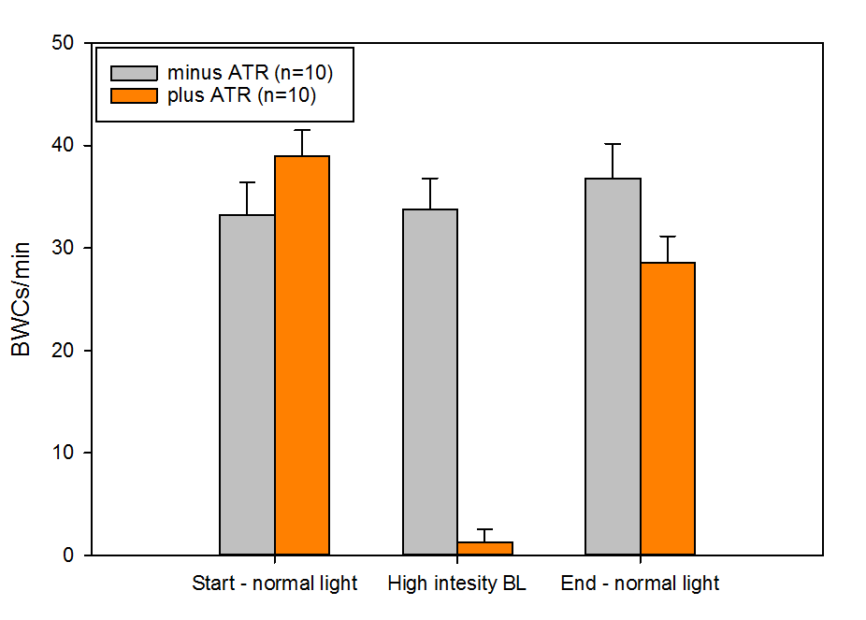

Figure 12: Serotonergic neuron activation modulates locomotor behavior in third instar larvae. To change serotonergic neuron activity, CHR2 were expressed in serotonergic neuron population (UAS-ChR2-XXL;Trh-Gal4). The body wall contractions were counted in third instar larvae fed on food supplemented with ATR 1 mM or ethanol (vehicle). When the larvae, which were fed on ATR 1 mM) were exposed to blue light (high intensity), the locomotor activity significantly compromised. However, when the larvae fed on a food without ATR supplementation were exposed to blue light (high intensity), the locomotor activity were not affected.

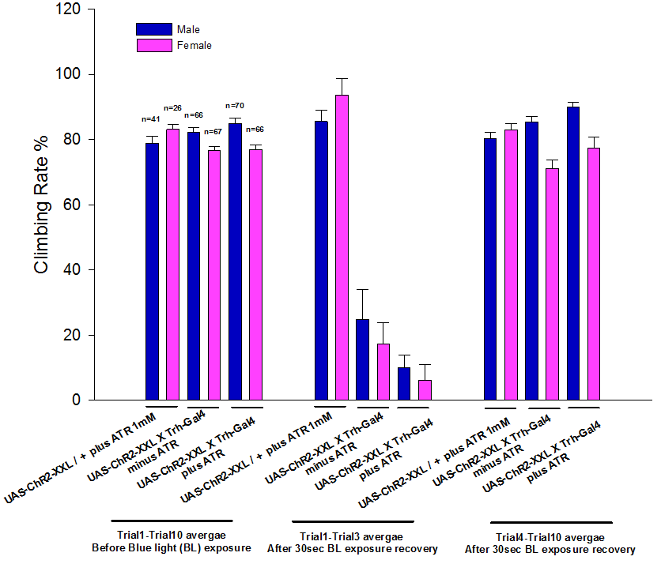

Figure 13: Activation of serotonergic neurons in adult flies decreases climbing ability. The electrical activity in serotonergic neuros is increased by expressing ChR2. When the adult flies were exposed to blue light (low intensity), the climbing ability significantly reduced. Both flies groups (UAS-ChR2-XXL;Trh-Gal4) which were fed supplemented with ATR 1mM or ethanol (vehicle) were affected by the blue light exposure. However, blue light did not have effect on the control lines (UAS-ChR2-XXl/+).

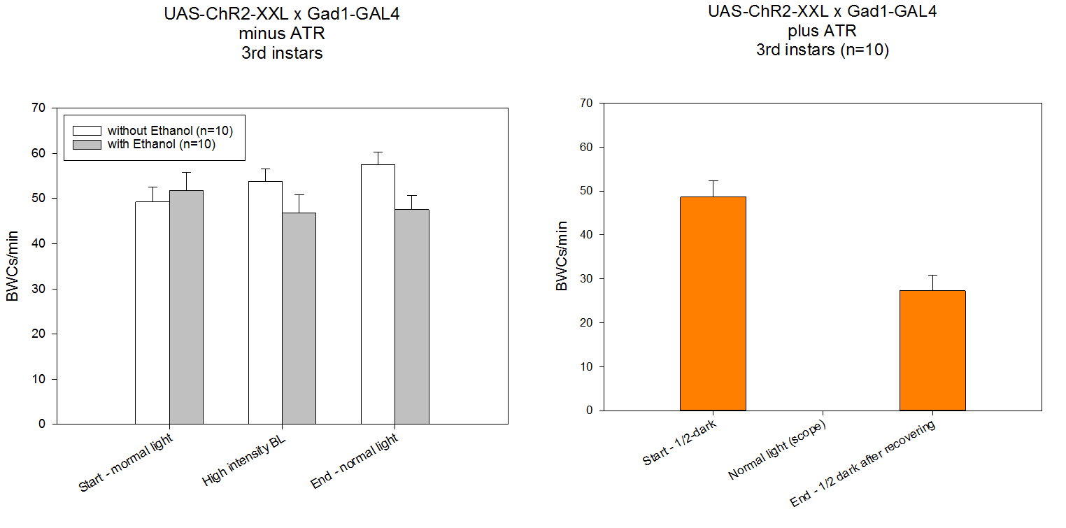
A
B

Figure 14: Manipulation of GABAergic neuron electrical activity diminishes locomotor activity in third instar larvae (UAS-ChR2-XXL;Gad1-Gal4). (A) The locomotor activity in larvae fed ethanol (vehicle) does not change with either normal white light or blue light exposure. (B) Although, when the larvae which were raised on food supplemented with ATR 1 mM are exposed to regular white light, the locomotor activity significantly decreased. During the exposure to white light, larvae started contracting which was followed by body muscle relaxation.

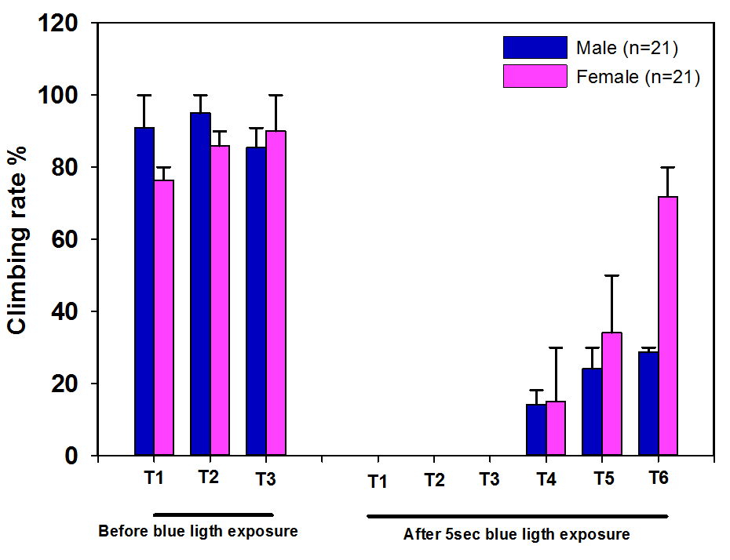

Figure 15: Climbing ability in adult flies expressing ChR2 in GABAergic neurons (UAS-ChR2-XXL; Gad1-Gal4) is compromised after 5 sec blue light exposure. The climbing ability was measured in three different trials before the blue light exposure. After 5 sec blue light exposure, the climbing ability was performed in six different trials. ChR2-XXL activation significantly reduced climbing ability. Flies were fed food supplemented with ATR 1 mM. The climbing assay was carried out a dim light room since the bright light might also activate ChR2 channels which make it difficult to perform the assay.

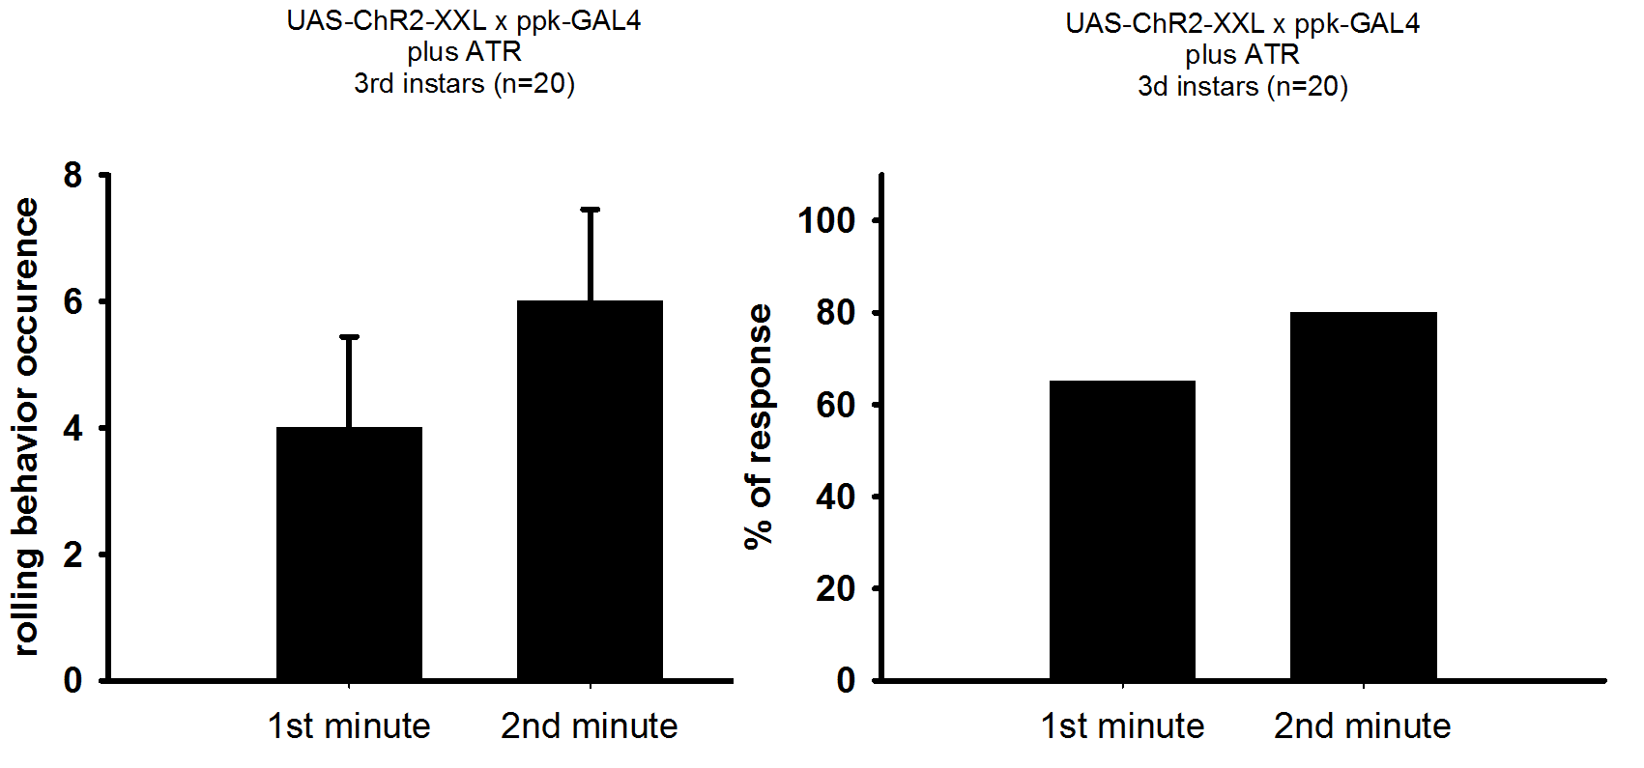
A
B

Figure 16: Rolling behavior is induced by activating ChR2 in type IV sensory neurons in third instar larvae (UAS-ChR2-XXL; ppk-Gal4 (n=20), food supplemented with ATR 1mM). (A) Shows the occurrence of rolling behavior in the 1st and 2nd minute of light exposure (normal scope light). (B) Most of the larvae showed rolling behavior when they are exposed to light.

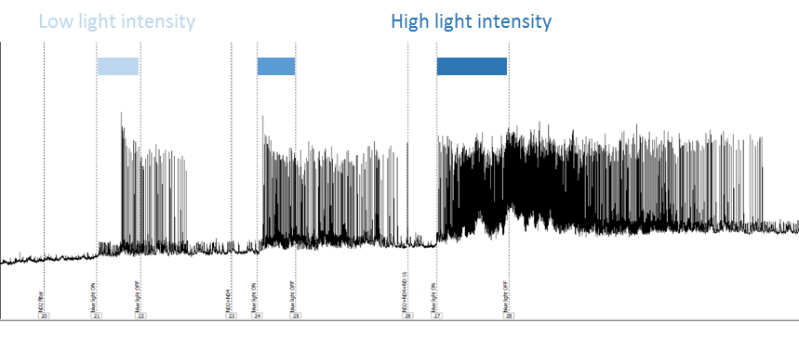

Figure 17: Intracellular EPSPs recording from body wall muscle fiber in third instar larva expressing ChR2 in type IV sensory neurons (UAS-ChR2-XXL;ppk-Gal4, food supplemented with ATR 1 mM). Activation of ChR2 in type IV sensory neurons makes motor neurons to fire action potentials which in turn depolarize muscle fibers. The motor output (ie., EPSPs traces) is being recorded while the third instar larva is being exposed to various intensity of blue light.

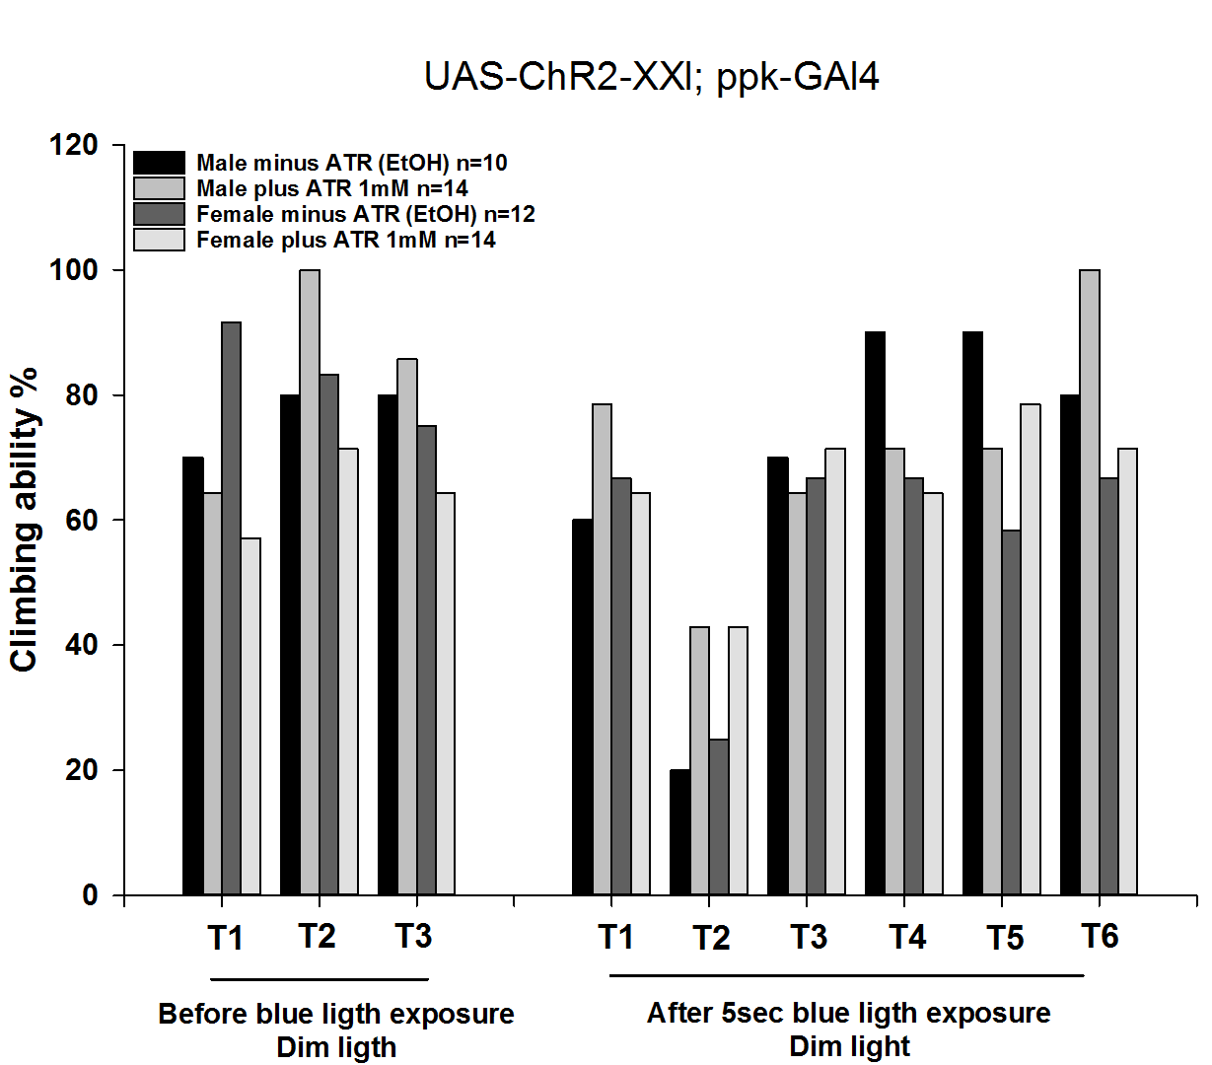

Figure 18: Type VI sensory neuron activity modulation affects climbing ability in flies expressing ChR2 in pickpocket neurons (UAS-ChR2-XXl; ppk-Gal4). After 5 sec blue light exposure, some of the flies were paralyzed for 1-2 seconds then they recovered well. As it is shown that the first trial (T1) after blue light exposure, the flies do well in climbing assay; although, in the second trial (T2 after blue light exposure), the flies climb the middle of the bottom tube then they stop climbing further. They recover quickly in the following trials.

References:

Ali, Y.O., Escala, W., Ruan, K., and Zhai, R.G. (2011). Assaying locomotor, learning, and memory deficits in Drosophila models of neurodegeneration. J. Vis. Exp. 11, pii 2504. doi: 10.3791/2504.

Badre, N.H., and Cooper, R.L. (2008) Reduced calcium channel function in Drosophila disrupts associative learning in larva, and behavior in adults. International Journal of Zoological Research 4 (3):152-164.

Balice-Gordon, R. J., Breedlove, S.M., Bernstein, S. and Lightman, J.W. (1990) Neuromuscular junctions shrink and expand as muscle fiber size is manipulated: in vitro observation in the androgen-sensitive bulbocavernosus muscle of mice. Journal of Neuroscience 10: 2660-2671.

Bradforth, S.E., Miller, E.R., Dichtel, W.R., Leibovich, A.K., Feig, A.L., Martin, J.D., Bjorkman, K.S., Schultz, Z.D., and Smith, T.L. (2015) University learning: Improve undergraduate science education. Comment. Nature 523: 283-284.

Chang, T.N. and Keshishian, H. (1996) Laser ablation of Drosophila embryonic motoneurons causes ectopic innervation of target muscle fibers. Journal of Neuroscience 16(18): 5715-5726.

Dawydow, A., Gueta, R., Ljaschenko, D., Ullrich, S., Hermann, M., Ehmann, N., Gao, S., Fiala, A., Langenhan, T., Nagel, G., and Kittel, R.J. (2014) Channelrhodopsin-2-XXL, a powerful optogenetic tool for low-light applications. Proceedings of the National Academy of Sciences of the United States of America 111(38): 13972-13977. doi: 10.1073/pnas.1408269111.

Ehlinger, D.G., Bergstrom, H.C., Burke, J.C., Fernandez, G.F., McDonald, C.G., and Smith,R.F. (2014) Rapidly emerging adolescent-nicotine induced dendritic remodeling is D1-dopamine receptor dependent. Brain Structure and Function http://dx.doi.org/10.1007/s00429-014-0897-3

Hubel, D. H., and Wiesel, T.N. (1970) The period of susceptibility to the physiological effects of unilateral eye closure in kittens. Journal of Physiology 206: 419-436.

Krajcik, J., and Merritt, J. (2012). Engaging students in scientific practices: What does constructing and revising models look like in the science classroom? Science and Children 49(7): 10-13.

Lichtman, J.W. and Sanes, J.R. (2003) Watching the neuromuscular junction. Journal of Neurocytology 32(5-8): 767-775.

Lomo, T. 2003. What controls the position, number, size, and distribution of neuromuscular junctions on rat muscle fibers? Journal of Neurocytology 32: 835-848.

McDonald, C.G., Dailey, V.K., Bergstrom, H.C., Wheeler, T.L., Eppolito, A.K., Smith,L.N., and Smith, R.F. (2005) Periadolescent nicotine administration producesenduring changes in dendritic morphology of medium spiny neurons fromnucleus accumbens. Neuroscience Letters 385(2): 163–167.

National Research Council. (2000). Inquiry in the national science education standards: A guide for teaching and learning. Washington, DC: National Academy Press.

NGSS Lead States (2013). Next generation science standards: For states, by states. Washington, DC: The National Academies Press.

Nichols, C. D., Becnel, J., and Pandey, U. B. (2012). Methods to Assay Drosophila Behavior. Journal of Visualized Experiments : JoVE, (61), 3795. doi:10.3791/3795

Pulver, S.R., Hornstein, N.J., Land, B.L., and Johnson, B.R. (2011) Optogenetics in the teaching laboratory: using channelrhodopsin-2 to study the neural basis of behavior and synaptic physiology in Drosophila. Advances in Physiological Education. 35(1): 82-91. doi: 10.1152/advan.00125.2010.

Schoofs, A., Hückesfeld, S., Surendran, S., and Pankratz, M.J. (2014) Serotonergic pathways in the Drosophila larval enteric nervous system. Journal of Insect Physiology 69: 118-25. doi: 10.1016/j.jinsphys.2014.05.022.

Smith, R.F., McDonald, C.G., Bergstrom, H.C., Ehlinger, D.G., and Brielmaier, J.M. (2015). Adolescent nicotine induces persisting changes in development of neural connectivity. Neuroscience and Biobehavior Review 55: 432-443. doi:
10.1016/j.neubiorev.2015.05.019. Epub 2015 Jun 3. Review PMID: 26048001

Waldrop, M.M. (2015) Why we are teaching science wrong, and how to make it right.
Nature News. Nature 523: 272-274.

Winnubst, J., Cheyne, J.E., Niculescu, D., and Lohmann, C. (2015) Spontaneous Activity Drives Local Synaptic Plasticity In Vivo. Neuron 87(2): 399-410. doi: 10.1016/j.neuron.2015.06.029. PMID: 26182421

